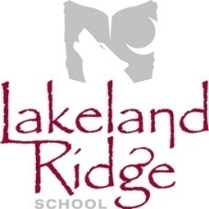**School Council Meeting Agenda**

**April 8, 2025**

**6:30 pm – 7:30pm**

**Library Learning Commons or via Microsoft Teams**

[**VIRTUAL MEETING LINK**](https://teams.microsoft.com/l/meetup-join/19%3ameeting_ZjM5YmY2MGUtODgwMi00ZDU1LTgyMDMtODU1MThmZGU5YWU4%40thread.v2/0?context=%7b%22Tid%22%3a%229e47afea-5e57-40c3-8443-f2df4a2f4b3f%22%2c%22Oid%22%3a%22d6adc2d3-4788-4eb4-b5d9-d7b555edd1a6%22%7d)

1. Opening remarks and welcome Andy Cunningham
2. Round table introductions All
3. Agenda amendments and approval Teresa Bladon
4. Approval of last meeting minutes Teresa Bladon
5. Reports
   1. EIPS Board Trustee Report Don Irwin
   2. Teacher’s Report Chantelle Robertson
   3. Administration Report Andy Cunningham
   4. COSC Report Teresa Bladon
6. Old Business
   1. Alberta School Council Engagement (ASCE) Grant Teresa Bladon
   2. Swim@School lessons Andy Cunningham

1. New Business
   1. ASCA Spring Symposium and AGM (Apr 26 and 27) Teresa Bladon
   2. Questions for Trustee candidates in Fall election Teresa Bladon

1. Next Meeting Teresa Bladon
2. Adjournment Teresa Bladon