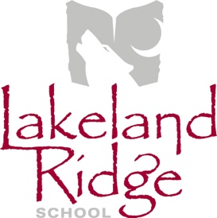
School Council Agenda
October 8, 2019
6:30 p.m.
Lakeland Ridge School Library

- Opening remarks and welcome April Childs
- Round table introductions All
- Agenda amendments and approval April Childs
- Approval of last meeting minutes April Childs
- Reports
  - EIPS Board Trustee Jim Seutter
  - Administration Report Jeff Huculak
    - School Education Plan
    - Accountability Pillar Results
    - PAT Results
  - PAS Report PAS representative
  - Mental Health Capacity Building Jasmyn Middleton
  - COSC Report April Childs
- Old Business
  - School Council Meeting Dates April Childs
- New Business
  - School Council Goals April Childs
- Next Meeting – November 19, 2019

- Adjournment

