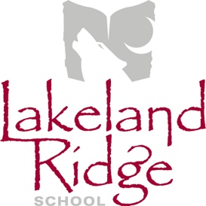
Annual General Meeting Agenda
October 16, 2018
6:30 p.m.
Lakeland Ridge School Library

- Opening remarks and welcome April Childs
- Round table introductions All
- Agenda amendments and approval April Childs
- Approval of last meeting minutes April Childs
- Reports
  - EIPS Board Trustee Annette Hubick
  - Administration Report LLR Admin Team
  - PAS Report PAS representative
  - Mental Health Capacity Building Erin Dawson-Meyers
  - COSC Report April Childs
- Old Business
  - School Council Meeting Dates April Childs
- New Business
  - School Education Plan Ryan Marshall
  - School Council Goals April Childs
  - Staff Appreciation April Childs
- Next Meeting – November 20, 2018

- Adjournment

