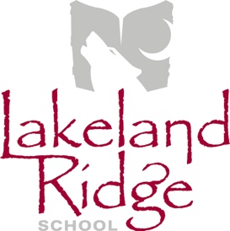
Annual General Meeting Agenda
September 18, 2018
6:30 p.m.
Lakeland Ridge School Library

- Opening remarks and welcome Ryan Marshall
- Round table introductions All
- School Council executive elections Ryan Marshall
- Appointment of minute taker (if position of Secretary is vacant) Chair
- Agenda amendments and approval Chair
- Approval of last meeting minutes Chair
- Reports
  - EIPS Board Trustee Annette Hubick
  - Administration Report LLR Admin Team
  - PAS Report PAS representative
- Old Business
- New Business
  - LLR School Council Meeting Calendar Ryan Marshall
  - School Education Plan Development Ryan Marshall
  - Discussion: School Council meeting topics and presentations All
  - Discussion: School Council events or initiatives All
- Next Meeting

- Adjournment

