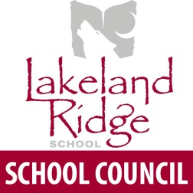
Meeting Agenda
6:30 p.m.
April 26, 2017
- Opening remarks and welcome Chair
- Round table introductions All
- Appointment of minute taker Chair
- Agenda amendments and approval Chair
- Approval of last meeting minutes Chair
- Reports
  - Administration LLR Admin Team
  - EIPS board trustee Trina Boymook
  - COSC/School Council Executive Annette Hubick
  - PAS Michelle Lyster
- New Business
- Discussion – Round 2 of proposed boundary changes All
for NE Sherwood Park
- Presentation of draft 2017-18 timetable (Parent Feedback invited) LLR Admin Team
- Planning for yearend staff appreciation Chair
- Bill 1 – Parent feedback on what types of fees are reasonable All
- Old Business
- Discussion and vote for LLR SC position on Alberta School Council All
Association proposed resolutions
- Discussion about Treasurer’s position and potential SC bylaw review Chair
- Next Meeting – Wednesday, May 31, 2017. Library.
- Adjournment
Handouts: 2017 ASCA Resolutions

